AIDI 1001 Conversational AI – Assignment 4: Alexa Conversations

# Assignment Overview

For this assignment you are to use Alexa Conversations to create a non-linear conversational experience for our users.

# Parameters

From the Alexa Console create a new Alexa Skill and choose the following settings. Choose the Pizza Ordering Sample Template

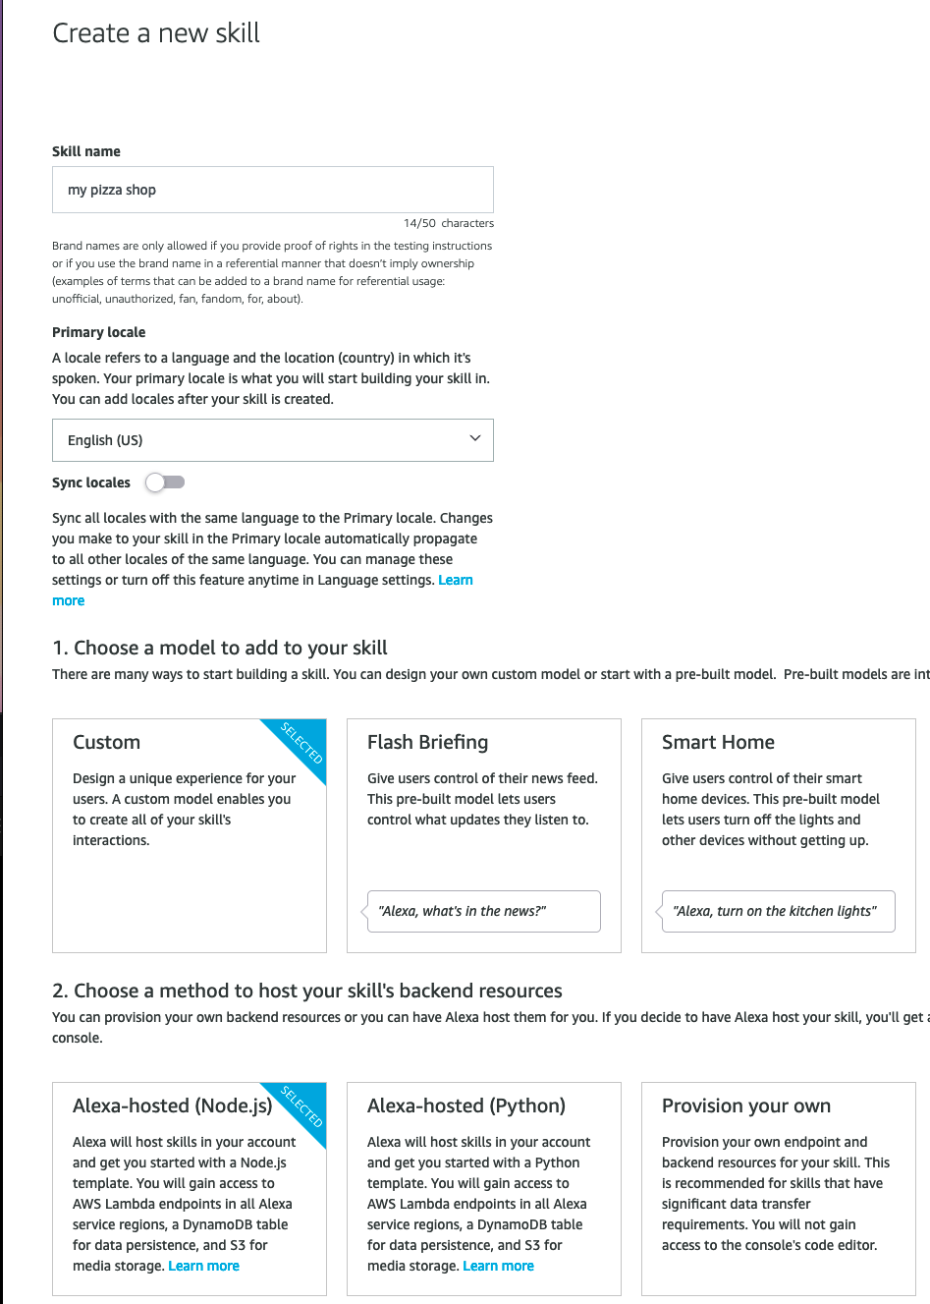

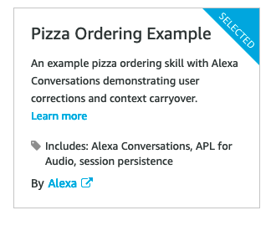

You are to create a new conversational pathway by adding at least 1 non pizza item to your menu. Some suggestions include sandwiches, salads or chicken.

* Modify the welcome to give your pizza shop a custom name. (2m)
* Create a dialog for ordering your new menu item (3m)
* Use at least two slots to describe your menu item.(2m)
* Create your API definitions (3m)
* Add responses (2m)
* Add Utterance Sets (3m)

Since this is a Node.JS application, you do not need to have the backend functioning. Only the front-end interaction models will be evaluated. However, you may wish to use the code below to prevent your intent from erroring. Replace “MenuItem” with your intent name.

const MenuItemHandler = {

canHandle(handlerInput) {

return Alexa.getRequestType(handlerInput.requestEnvelope) === MenuItem;

},

async handle(handlerInput) {

return handlerInput.responseBuilder

.speak(handlerInput.t(‘Say something here to confirm your menu item’))

.reprompt(handlerInput.t('NO_NAME_PROMPT'))

.getResponse();

}

};

At the bottom of the code don’t forget to add this line below around line #577 inside the .addrequestHandlers.

MenuItemHandler,

# Submission

To submit your assignment for marking provide a screen cast video that shows the dialog, API Definitions, utterance sets and responses for your new menu item.

A demo of your ordering the menu item.